[Type here]

EQUALITY, DIVERSITY & INCLUSION policy – version 1

Dates Approved for use 21st April 2026
Approved by David Helyer
Date for review 21st April 2027

EQUALITY, DIVERSITY & INCLUSION POLICY

Each Service User and their family within Attentive Care Solutions will be treated with equal concern and no discrimination will be made based on ethnic origin, colour, religion, class, gender, disability, age, language, nationality or sexual orientation. We will help service users celebrate the things that make them unique thus promoting a feeling of pride and raised selfesteem.

It is our policy to extend equal opportunities to each service user to fulfil their full potential of learning and developing. We will take into consideration the age, gender, stage of development, ethnic origin, native language and ability.

It is our policy to challenge discriminatory comments, attitudes and behaviour from any children in my service and from other adults.

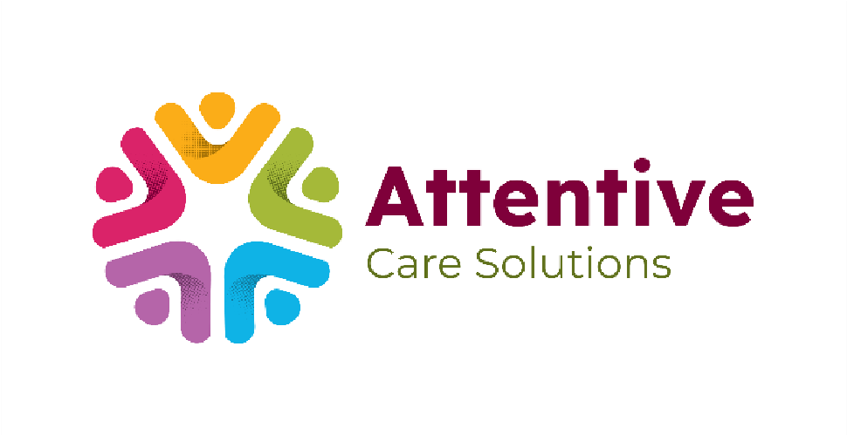
We are fully committed to teaching children about the differences between us and encouraging the celebration of the uniqueness of each one of us.

We are aware of all legislation and existing codes of practice regarding equality such as those laid out by the Equality and Human Rights Commission, and we are fully committed to satisfying these basic principles in all of my activities.

Should you have cause to make a complaint about unfair treatment or unlawful acts of discrimination you are requested to do so without prejudice or fear of recrimination by following our complaints procedure.

